**Check Orphaned Snapshot**

1. Login to <https://628471438687.signin.aws.amazon.com/console>.

2.Switch **to SAP_NONPROD++|++852956782656** (same check for **SAP_PROD** And **Shared_services**)

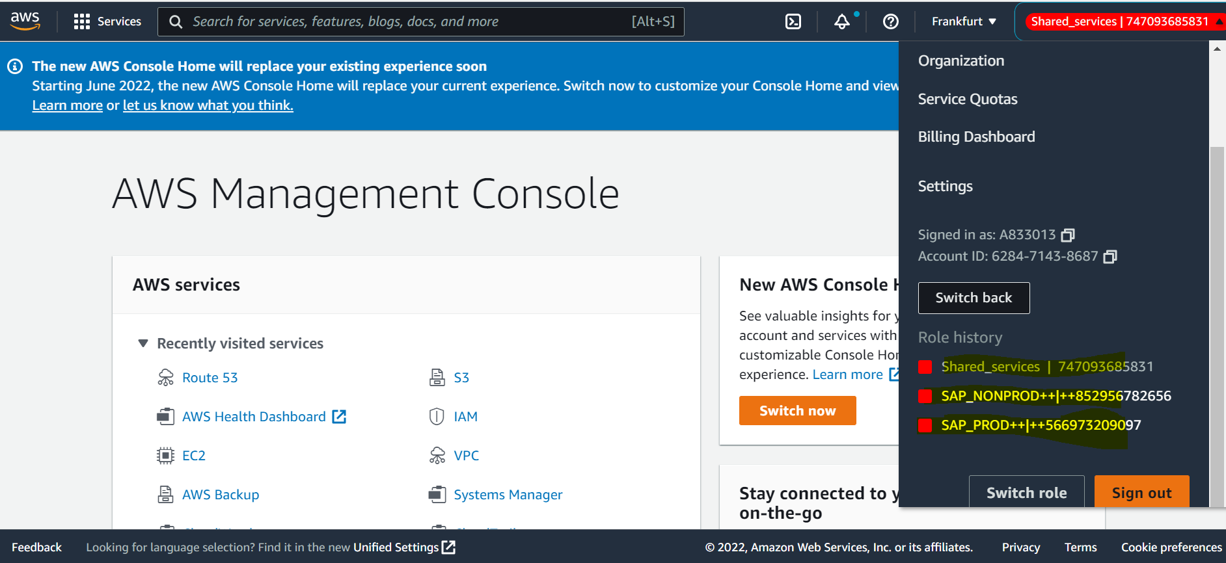

3.Search for EC2 in search box.

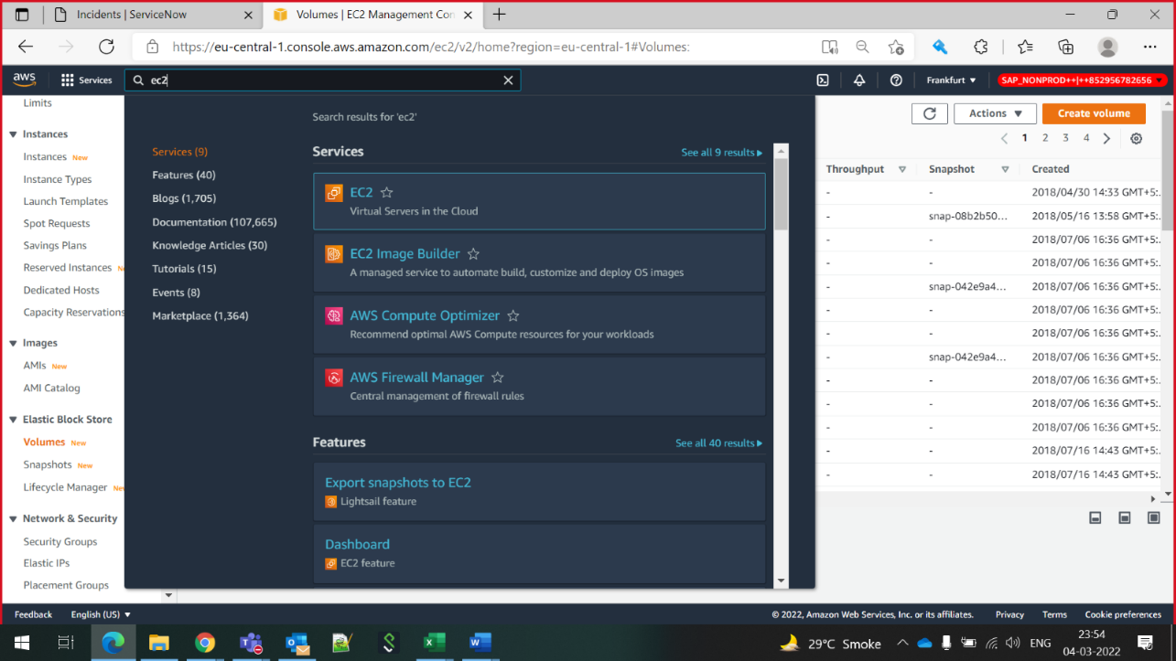

4. click on snapshots

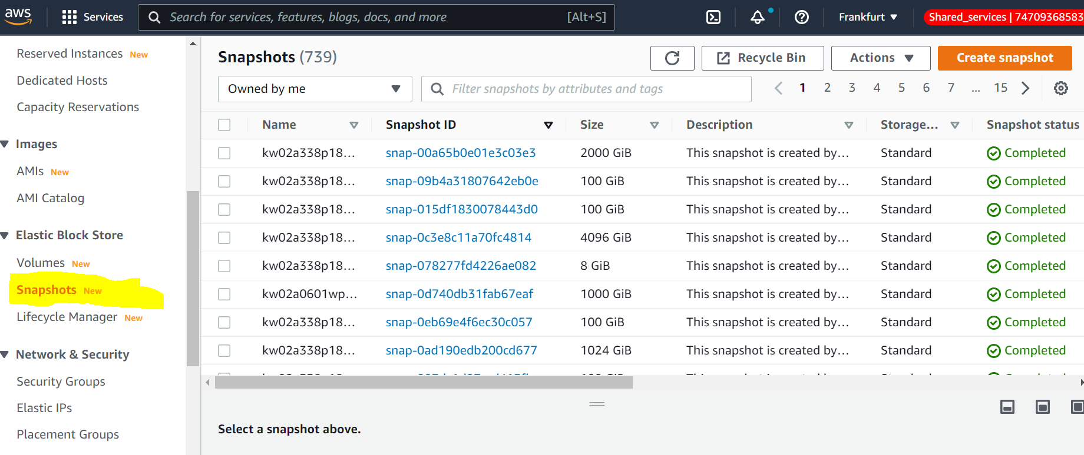

5. In search box type Started. Click on started

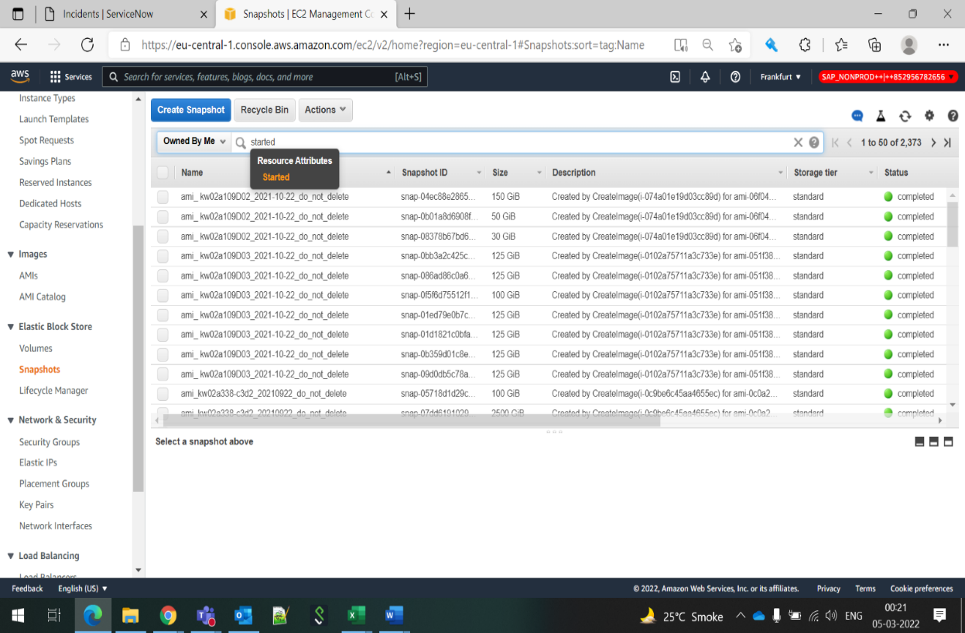

6.Select appropriate date as per account.

For SAP_NONPROAD Account -BEFORE 14 DAYS

FOR SAP_PROD Account -BEFORE 30 DAYS

FOR SHAREAD SERVICES -  BEFORE 30DAYS.

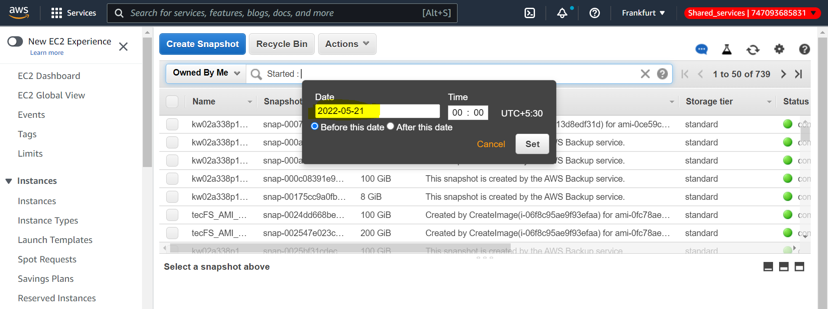

7. after filtering date if there is **Snapshots** older than (14d,30d) it will show .so monitor and update same.

**Make a Excel sheet  of older AMI’S and SANPSHOTS and check with customer which can be deleted.**